ASD Project

Member:

* Tri An Vuong - ID 615629
* Dinh Huy Dang - ID 615944

**Part A:**

Write your own Spring Framework that instantiates all classes that are annotated with @Service. The framework should also apply dependency injection to all fields that are annotated with @Autowired.

* Define annotation @Autowired and @Service

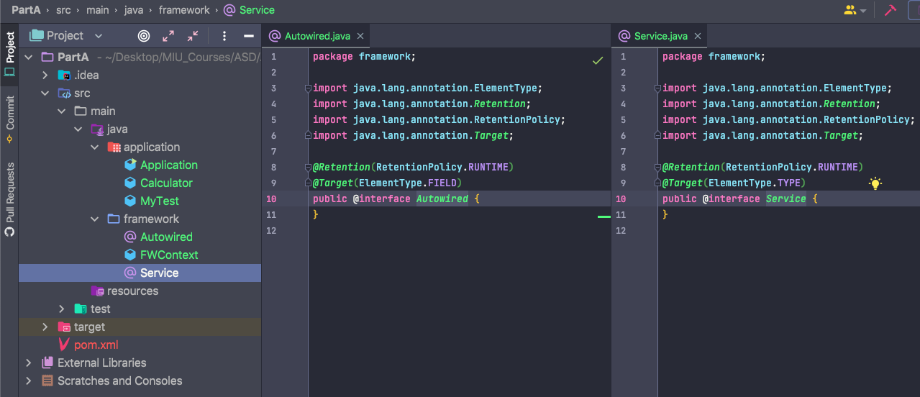

* In application, we create Calculator and MyTest service. The MyTest service inject Calculator

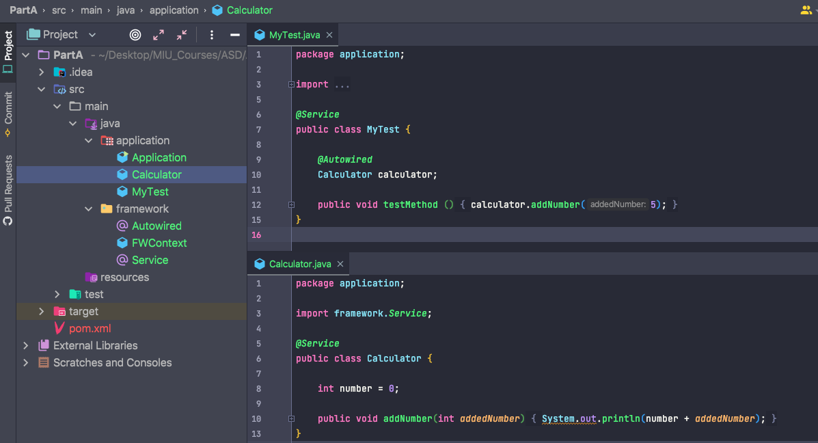

* Run Application successfully

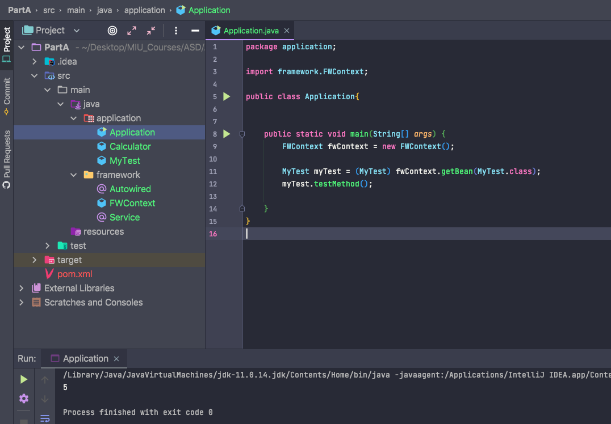

**Part B**

* Create annotation @Qualifier

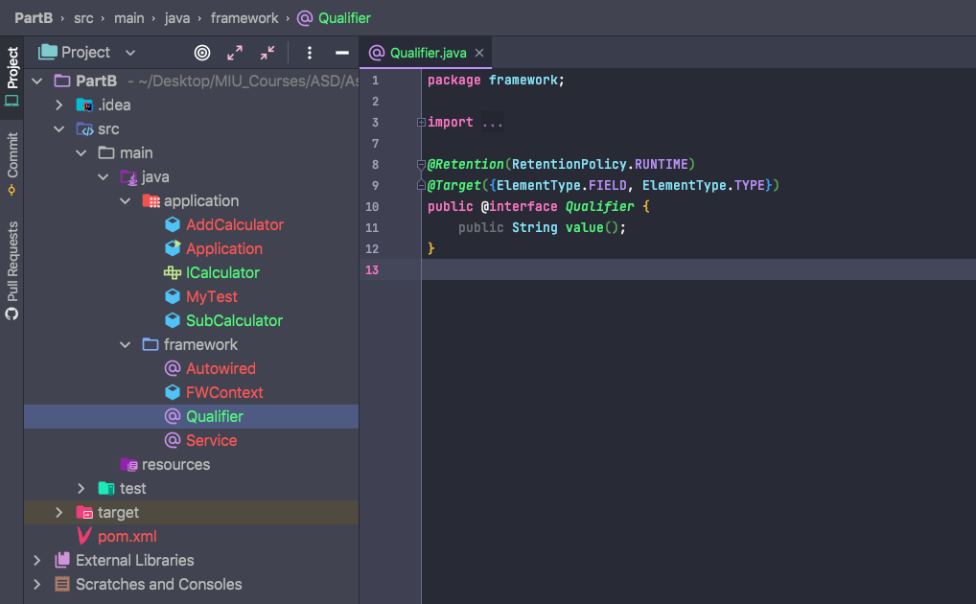

* AddCalculator and SubConculator implement IConculator interface

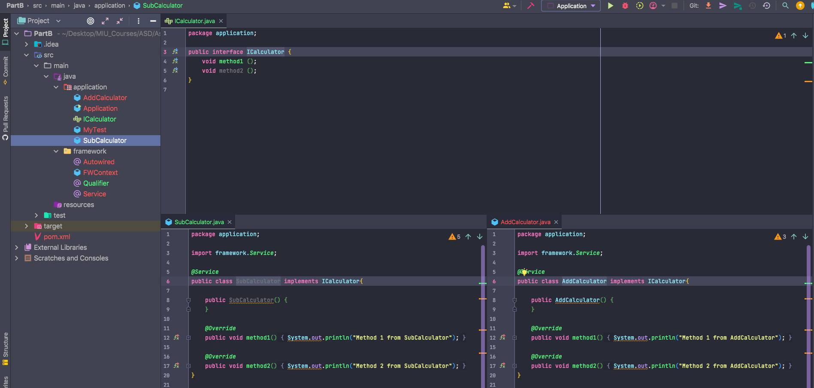

* MyTest service inject IConculator with @Qualifier value point to SubCalculator Service

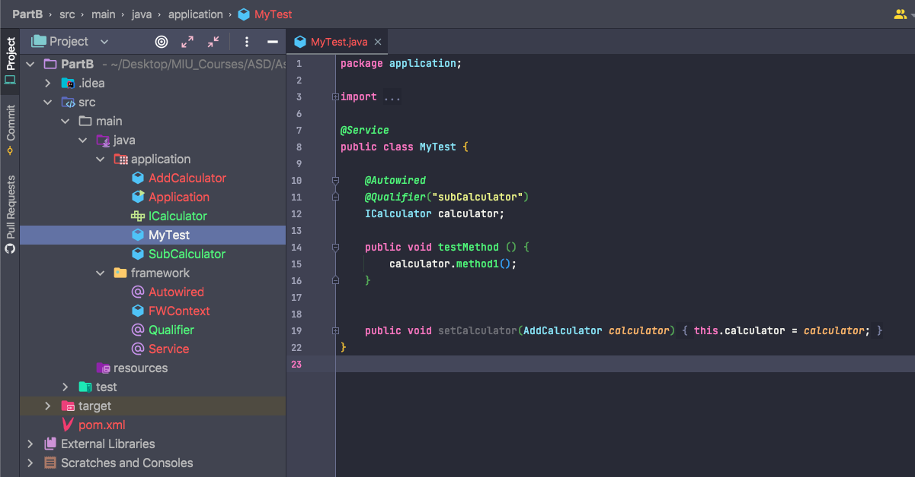

* Run Application successfully

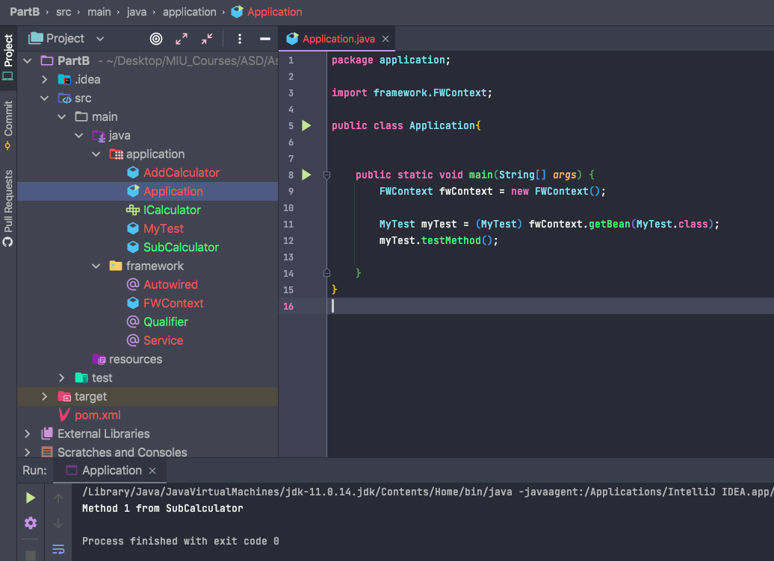

Part C

* Create annotation @Value

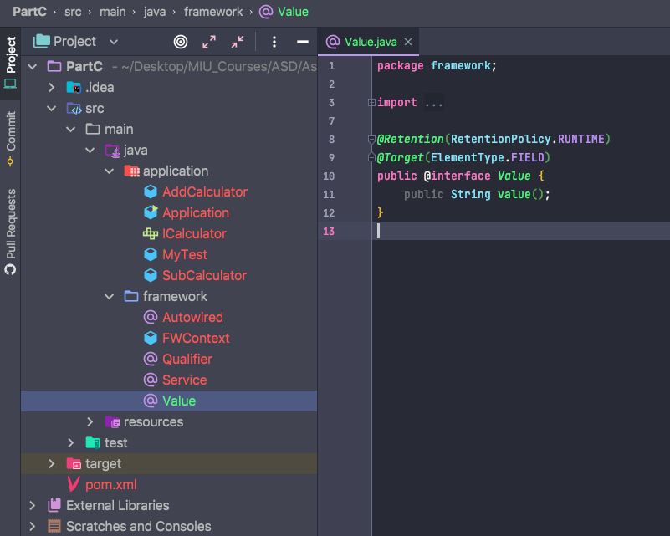

* Create application.properties

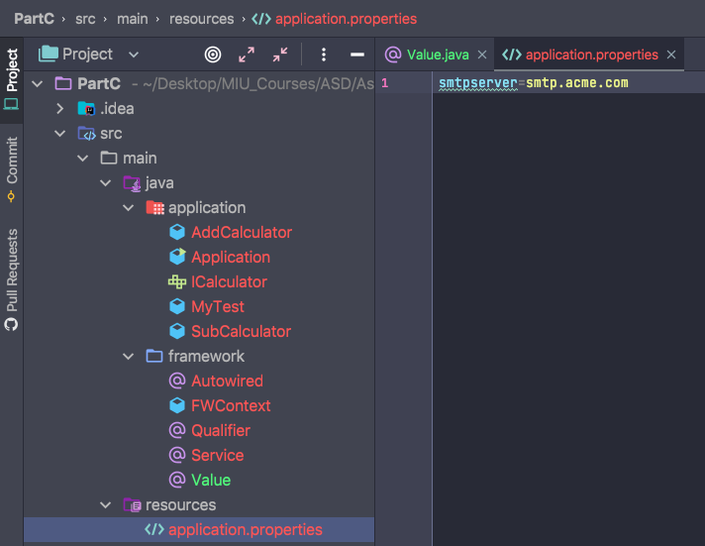

* In SubCalculator service, create variable with @Value annotation to get value from application.properties

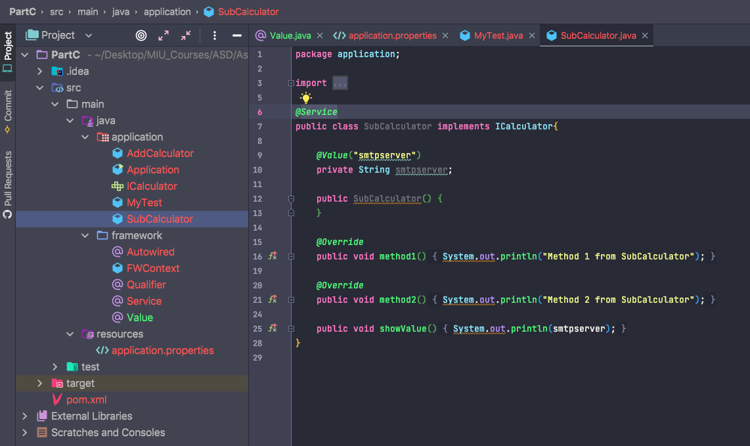

* Run application successfully

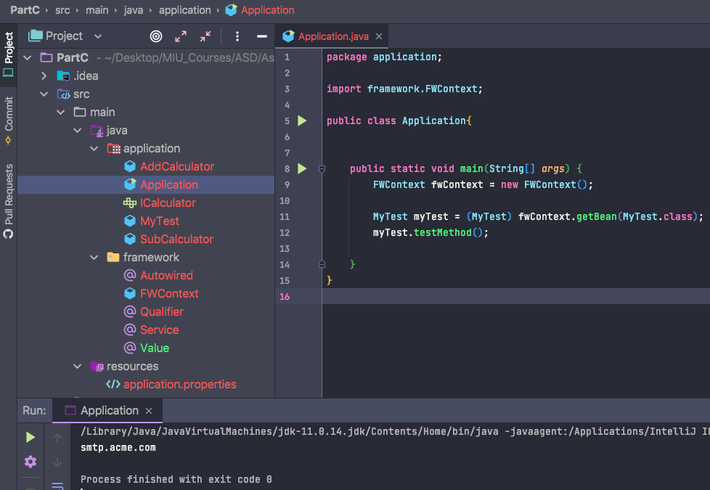

Part D

* Create FWApplication with run method. Then Application can implement Runnable and run Application successfully.

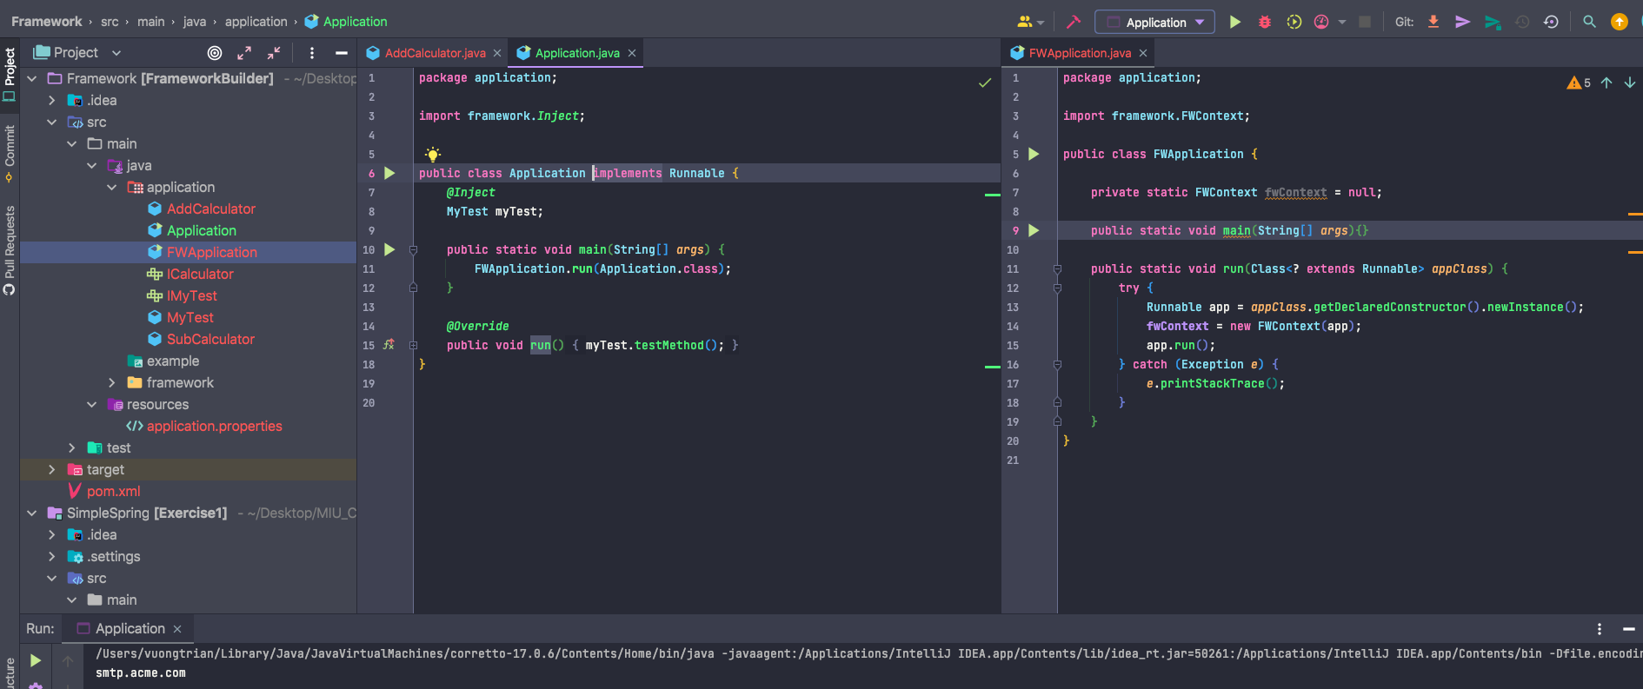

* Build maven to Jar file

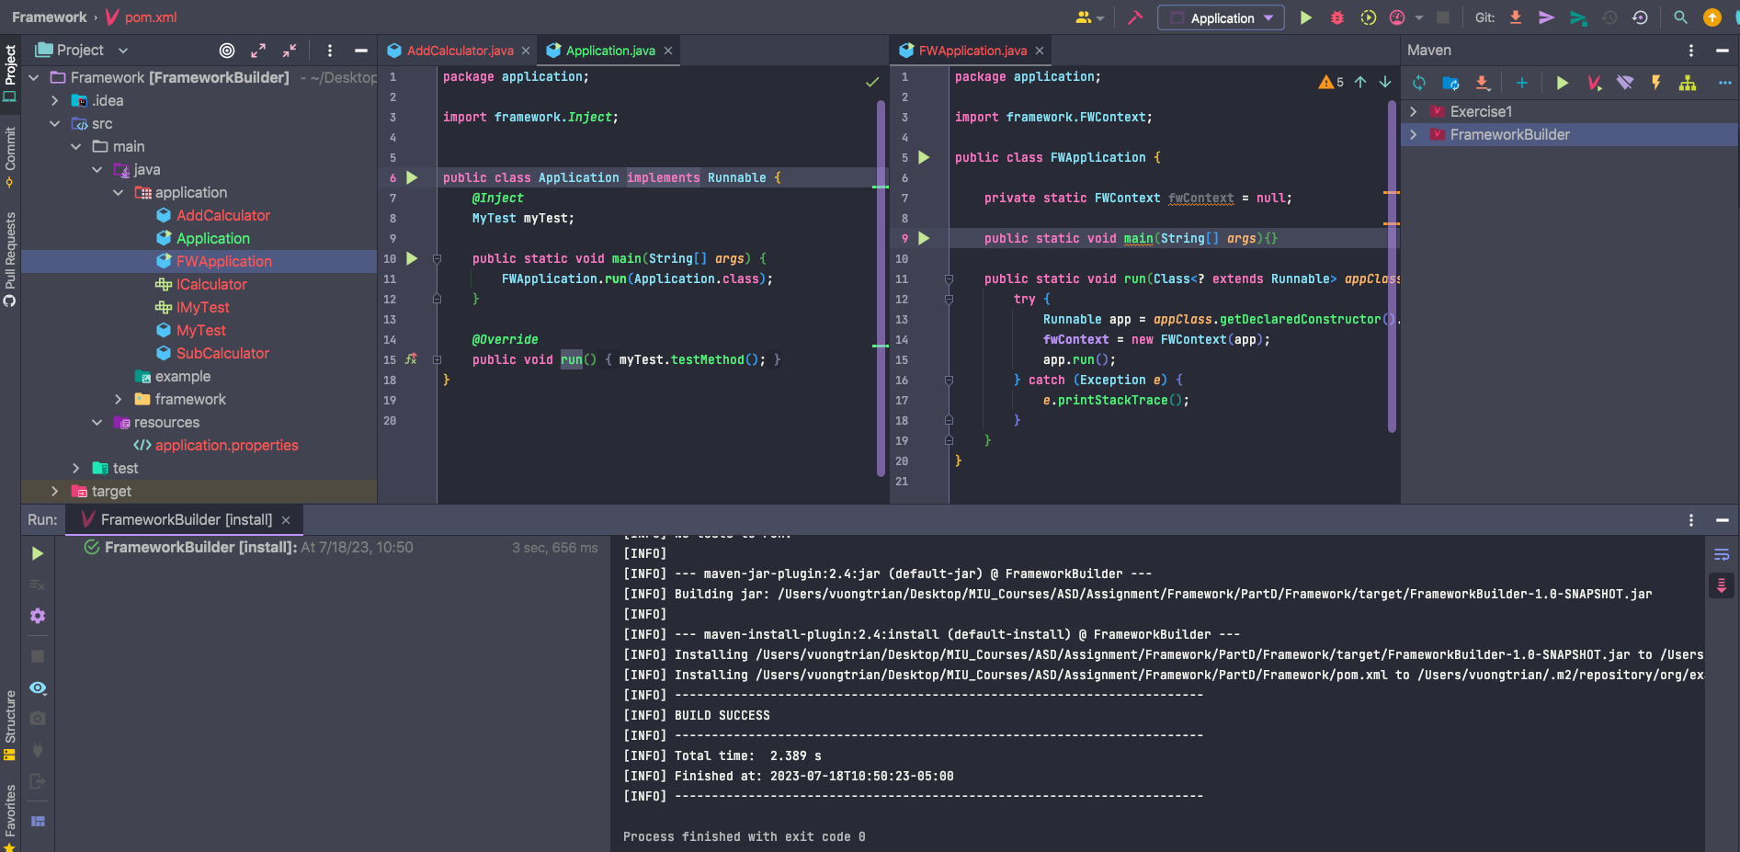

* In Spring application, add dependency of Framework

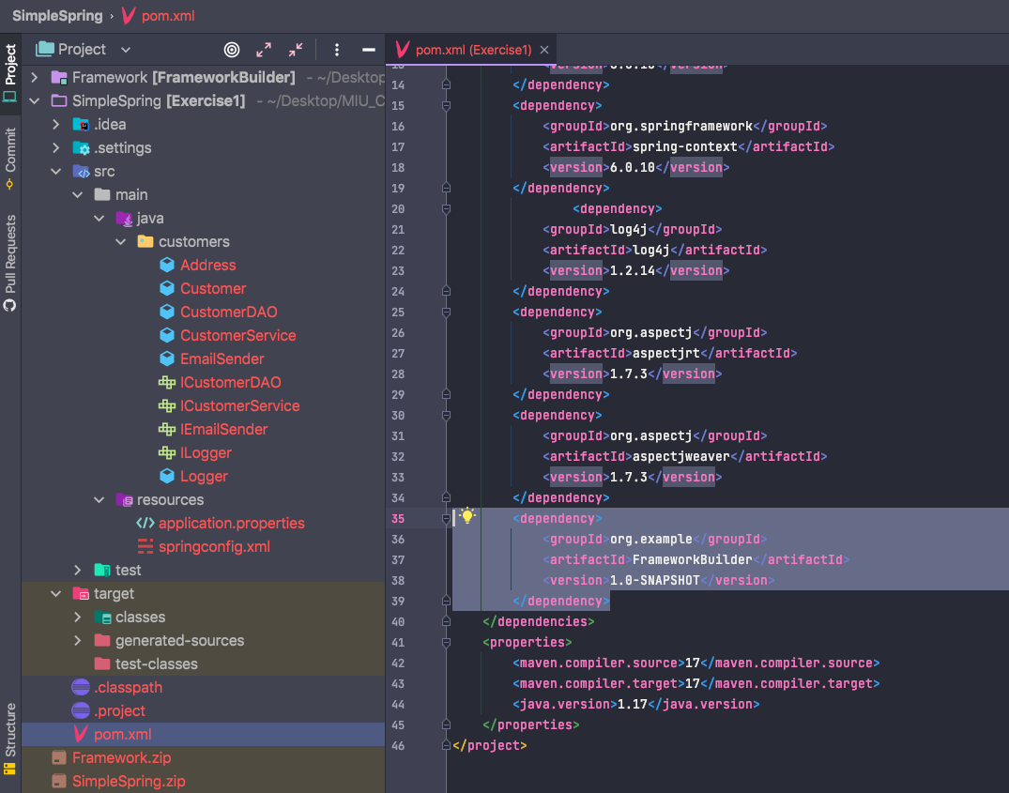

* Run Spring application successfully

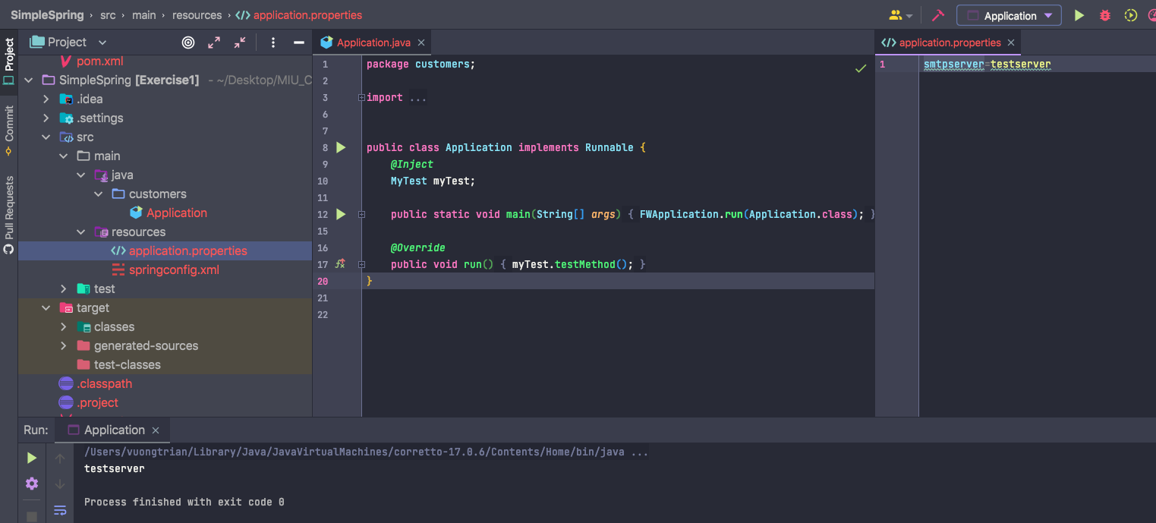

Part E

* Create @Profile annotation

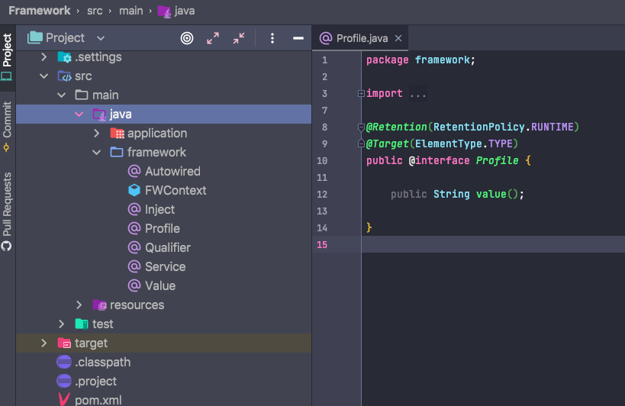

* Create MockCalculatorDAOImp with @Profile annotation, value is Test

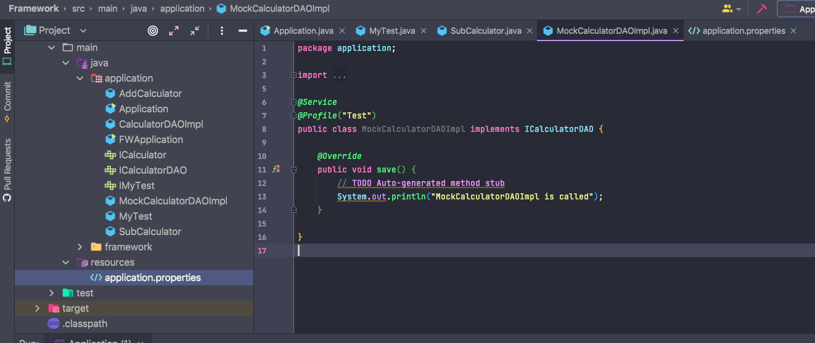

* Active profile Test in application.properties

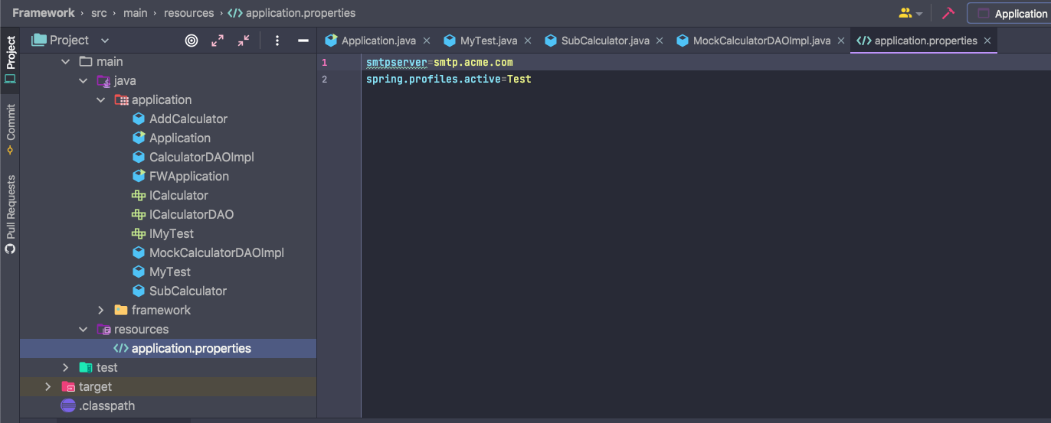

* Run application successfully

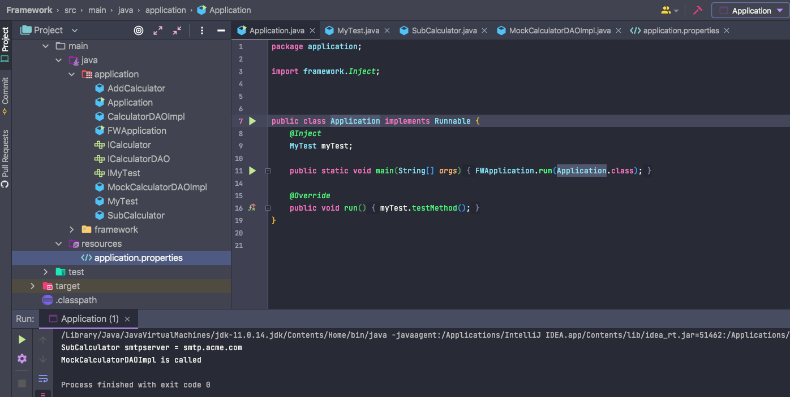

Part F

* Create @Schedule annotation

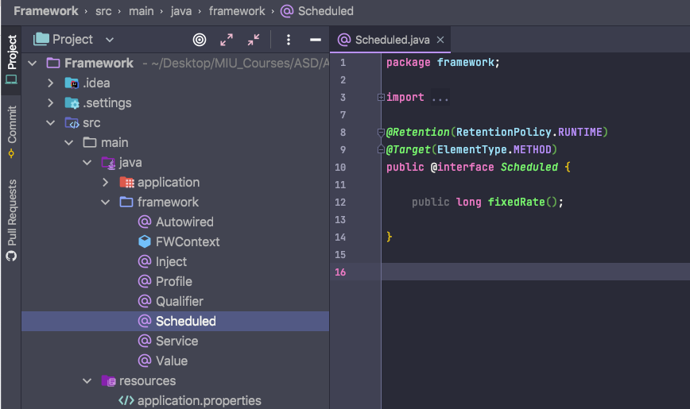

* Create LoggerSchedule and set @Schedule with 2 seconds

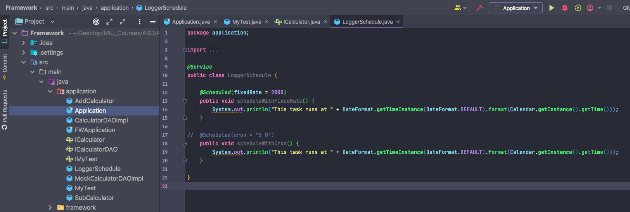

* Run application successfully

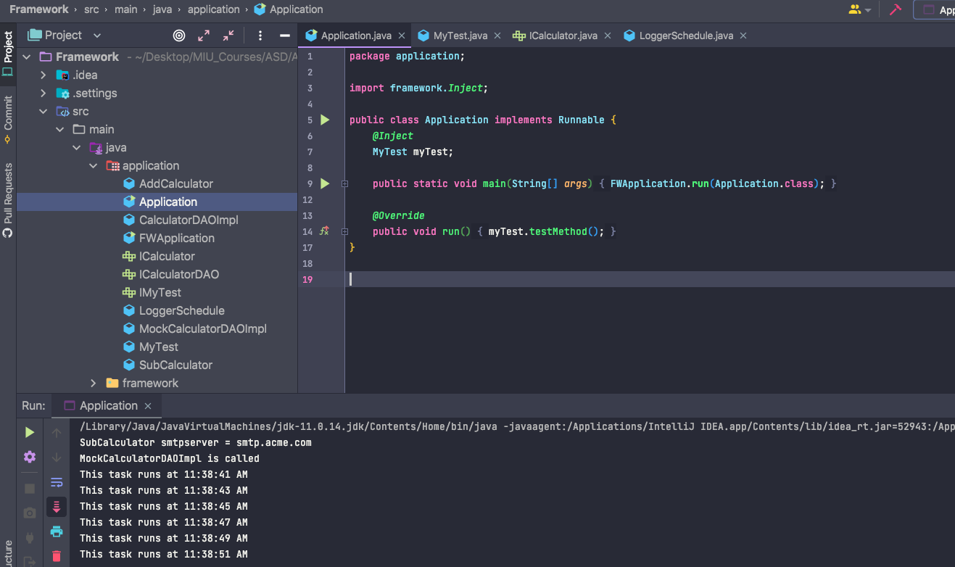

Part G

* Modify @Schedule annotation

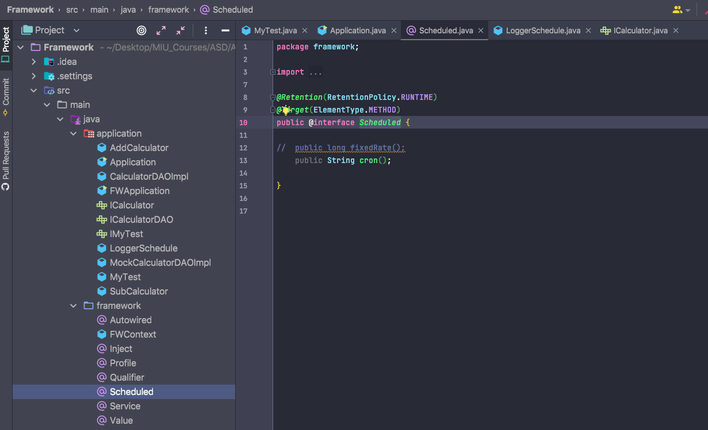

* Modify LoggerSchedule

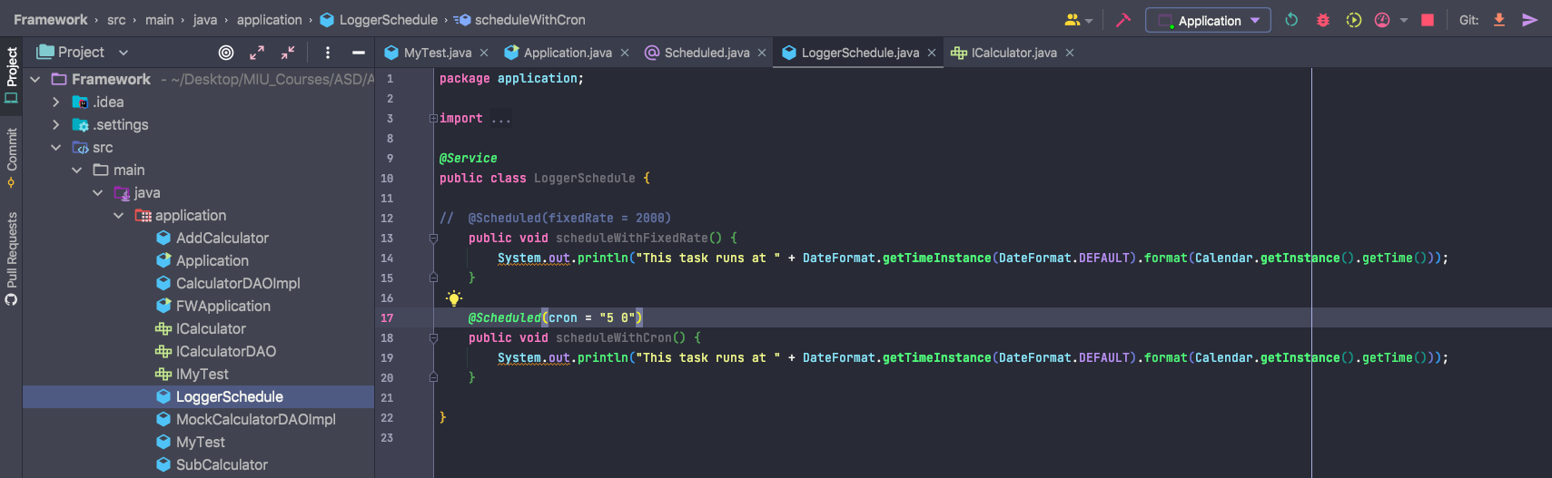

* Run application successfully

